Updating your commitments made at the
Global Disability Summit

If you made a commitment at the 2018 Global Disability Summit (GDS), we encourage you to submit an update on the progress your organization has made on these commitments. Follow this step-by-step guide below to do so!

Step 1.
Click here to access the commitments portal website where the updates can be submitted.

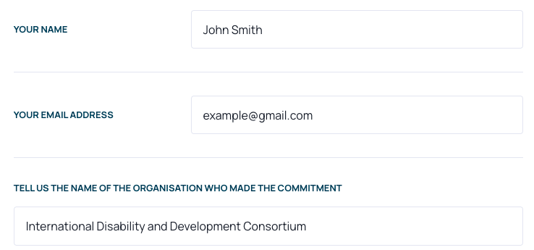
Step 2.
Enter your:
- Name
- Email address
- Organization

Step 3.
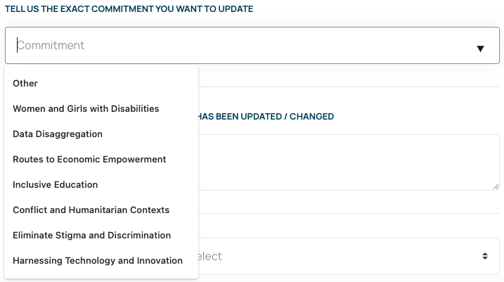
Select the exact commitment you
want to update

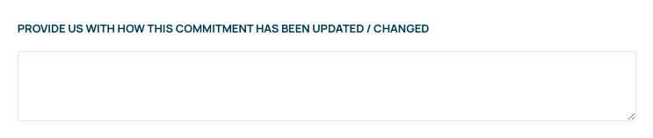

Step 4.
Give a short explanation of the commitment’s progress

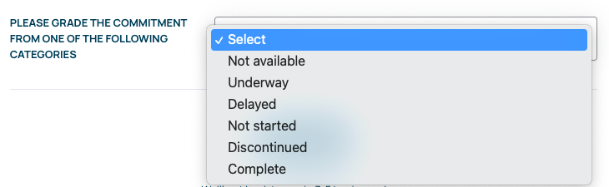
Step 5.
Select the commitment’s
level of progress

Step 6.
Click ‘Send it now’

Step 7.
The GDS secretariat will cross check the commitment you submitted with the focal point we have for your organization. We aim to get back to you within 7 business days. For any questions, please write to summit@ida-secretariat.org

