Civil Society Forum under the auspice of

the Global Disability Summit 2022

15 February 2021

Proposed agenda

The following agenda has been prepared by the Global Disability Summit Secretariat. We have built the proposed agenda based on an online global consultation we conducted with Civil Society on the topics of the Civil Society Forum. We received a total of 190 responses, highlighting the interest from civil society in providing inputs to the Forum. Through the form, we asked respondents to indicate their preferences for themes for discussion. The consultation highlighted a need for sessions that would address multiple points in an over-arching manner.

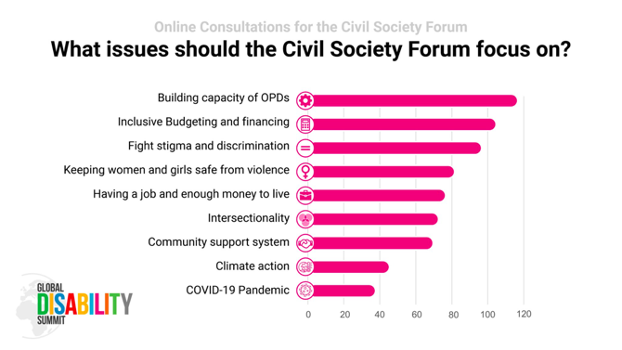

Background

In consultation with civil society partners, IDA and the Atlas Alliance will be organising a Civil Society Forum, as an addition to the Summit, to leverage the opportunity to amplify the voice and participation of persons with disabilities, through their individual participation and that of representative organizations (OPDs). The Forum is an opportunity to highlight current issues relevant to the global disability movement and realization of the CRPD, that will not specifically be addressed at the Summit. The intention is not to duplicate the points that will be made at the Summit, rather provide additional space for Civil Society to makes its own contribution to the Summit. The Forum will also set the stage for the more specific dialogues at the Summit on the specific thematic areas.

Agenda (all times CET)

14.00 – 14.30

Opening Session

This session will be used as a scene setter and as an opportunity to tie the Civil Society Forum with the GDS mechanism. A draft declaration will be presented, to be finalized with inputs from the Forum itself.

Objectives:

1) to introduce the Civil Society Forum within the GDS mechanism, from local to global

2) to promote the cooperation between OPDs and NGOs for the implementation of the CRPD

14.30 – 15.30
Session 1: Creating synergies and partnerships
Session objective:
In this session, we will focus on capacity-building of OPDs, looking both at organizational development and the way OPDs can work with each other and in synergy with other stakeholders to bring about change. Speakers would discuss opportunities for meaningful participation of persons with disabilities in the development agenda [funding and inclusive programming /OPD capacity building / coordination among OPDs and INGOs / meaningful engagement in advocacy efforts be that climate change, gender, youth]

Attendees/persons with disabilities would address the following:
- What is inclusive programming and budgeting
- How to secure coordination between OPDs and INGO’s
- Enhancing Capacity , to ensure meaningful engagement of OPDs
- Advocacy: how OPDs can be involved in and lead the advocacy – steps to get there; good practices

30 minutes for interactive Q&A

15.30 – 15.45: Break
The CSRG will confirm what will happen during the break

15.45 – 16.45
Session 2: Perspectives on an inclusive future – way forward after GDS

Session objective:
This session will serve as a reflection on what are inclusive ways to progress as a society after GDS 2022.

Attendees/persons with disabilities would address the following:
- Covid and the CRPD – where do we need to act most urgently now?
- Testimonies on how it has impacted persons with disabilities, especially women and girls with disabilities, and particularly marginalized groups within the disability community
- Advocacy strategies towards fighting stigma & discrimination
- Tracking inclusive funding and programming

30 minutes for interactive Q&A

16.45 – 17.15
Closing session [adoption of the declaration / call for action]

Moderator:

Speakers:

***

