CONCEPT NOTE FOR A SIDE EVENT TO THE GLOBAL DISABILITY SUMMIT 2022
Title: “Social and Financial Inclusion: lessons from cooperation of Organizations of People with Disabilities (OPDs) and mainstream development agencies in promoting disability inclusion”
While numerous development agencies including International Non-Governmental Organizations (INGOs), Organizations of Persons with Disabilities (OPDs) and Microfinance Institutions (MFIs) have committed to fostering disability inclusion and sustainability, a good number are grappling with how to exactly Mainstream disability and report about the same. This is partly because of the scanty information and research on disability coupled with the variations in orientation and focus for instance, MFIs are profit making in nature while INGOs and OPDs are mainly driven by social value.
Based on practical experience of the Together for Inclusion (TOFI) consortium where the INGO; - Stromme Foundation, OPDs; - Norwegian Association of Disabled (NAD) and National Union of Disabled Persons of Uganda (NUDIPU) and an apex body for microfinance Institutions; - Association of Microfinance Institutions of Uganda (AMFIU) are implementing the iSAVE Inclusive Economic Empowerment program in Uganda as a partnership.
NAD, Stromme Foundation, NUDIPU and AMFIU are presenting the side event with a purpose to demonstrate how strategic partnerships can effectively promote social and financial inclusion. This is premised on the lessons learnt as well as the willingness for good practices by INGOs, MFIs and OPDs which energizes potential of persons with disabilities.
Particular attention will be placed on:
- Mutual cooperation, sharing of good practices and adaptations needed in promoting inclusion
- How provision of business training and financial support paves way for employment of persons with disabilities.
- Effective community awareness raising, and provision of vocational training creating opportunities to formal employment for persons with disabilities
- Building sustainable social safety net for persons with disabilities
The participants will learn how social performance indicators, demographic data collection, improved accessibility can be fostered through unique ties between ODPs, MFIs, INGOs and other players for instance in the research, public and private sector for sustainable disability inclusion.

Speaker 1:

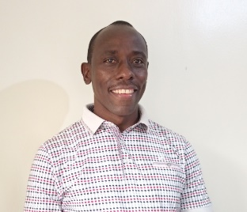
George Mukasa Mukisa is the Technical Adviser at the Norwegian Association of Disabled (NAD). He is the lead organizer of NAD’s iSAVE Inclusive Economic Empowerment Program and partners at regional and global levels. As a trainer and facilitator, he builds partners’ capacities on project design, implementation and management, leadership, collaboration, and communication.
George has over sixteen years of experience in incubating and managing an intersection of microfinance, NGO work, project management, community development work and research. He is passionate about serving vulnerable communities and his trades include Organizations of Persons with Disabilities (OPDs), Savings Groups programs, private microenterprises, and community development organizations. He is based at NAD Uganda offices.

Speaker 2:
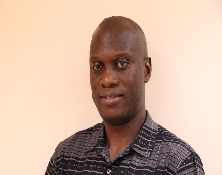
Joseph Walugembe is the Project Coordinator: Together For Inclusion - Uganda and South Sudan at the Stromme Foundation East African Regional Office where he leads the Inclusive Education and Inclusive Economic Empowerment programs.
Grounded in Disability Inclusive Development, Joseph has strategically guided programs on Inclusive Education, Inclusive Economic Empowerment, capacity building for Organizations of People with Disabilities, Inclusive Peace and Conflict Resolution, mitigation of sexual and gender-based violence against girls and women with disabilities as well as Inclusive HIV/AIDS response.
He has extensive knowledge of the Convention on the Rights of Persons with Disabilities, and national legal, policy and institutional frameworks for the promotion of human rights and inclusion of people with disabilities.
Previously Country Director for ADD International, Country Development Manager for Sense International and Regional Advocacy Coordinator at the African Union of the Blind.

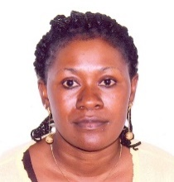
Speaker 3:

Flavia Nakabuye Bwire is the Manager – Membership & Inclusion at the Association of Microfinance Institutions of Uganda (AMFIU) an umbrella organization that promotes professionalism and financial deepening of the microfinance industry in Uganda. As a practitioner and expert on disability inclusion, Flavia has spoken at various forums, including the European Microfinance Platform, Luxemburg, Conference of State Parties, New York, European Development Days, Brussels, Global Microcredit Summit, Valladolid, European Investment Bank Board Seminar, Inclusive Microfinance Conference, Kampala among others. She holds a Masters in Management Science, PG in Financial Management, Bachelor of Education and numerous Certificates in Microfinance, Project Management, and Business Development Services. Flavia has 20 years’ hands-on experience in inclusive finance practices and is a certified Financial Literacy trainer (Bank of Uganda).

Speaker 4:

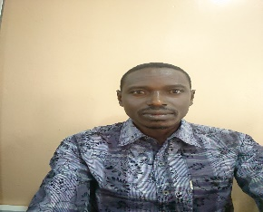
Yofisa Oyuki holds a Master’s degree in Public Health, a Bachelor of Environmental Management, Post Graduate Diploma in Project Planning and Management and currently completing a Masters’ degree in Monitoring and Evaluation.
Oyuki is currently a program Manager Economic Empowerment at National Union of Disabled Persons of Uganda (NUDIPU), an indigenous umbrella body that brings together all disability categories in Uganda.
Oyuki has ten years’ experience in Programme Management. Providing leadership in programming, Economic Empowerment and disability inclusion. He has developed capacities in program design, monitoring and evaluation - intersecting Civil society organizations, Organizations of persons with disabilities and government.

