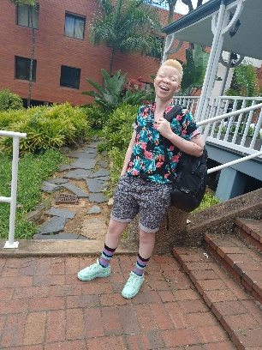
Hlobisile Masinga,
Founder and Chairperson of The Pink Roses Foundation

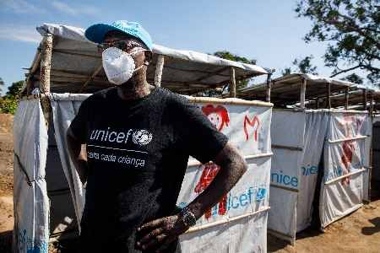
Mohamed Malick Fall
Regional Director,
UNICEF Eastern and Southern Africa Regional Office

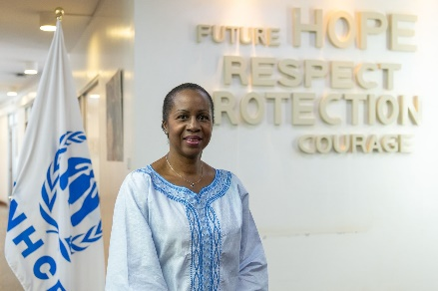
Clementine Awu Nkweta-Salami,
Regional Bureau Director for the Easter, Horn and Great Lakes Regions of Africa

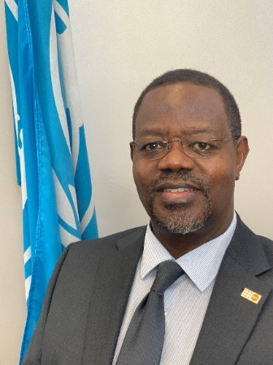
Dr. Bannet Ndyanabangi,
Regional Director,
UNFPA Eastern and Southern Africa Regional Office

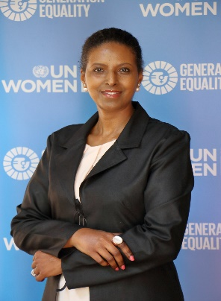

Zebib Kavuma, Deputy Regional Director, UN Women Eastern and Southern Africa Regional Office

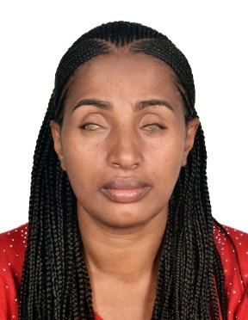
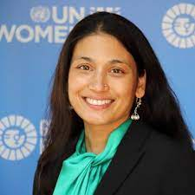
Sunita Caminha,
Ending Violence against Women Policy Specialist and Disability Focal Point, UN Women East and Southern Africa Regional Office

Yetneberesh Nigussie Molla,Disability Inclusion Specialist,
UNICEF Eastern and Southern Africa Regional Office

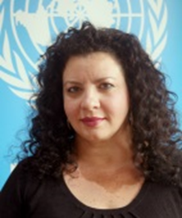
Maria Bakaroudis,
Comprehensive Sexuality Education Specialist & Disability Focal Point, UNFPA East and Southern Africa Regional Office

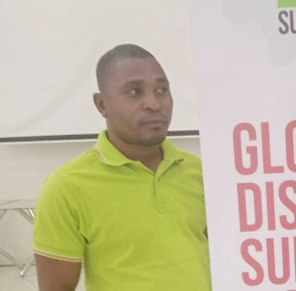

Amimo Maquina,
Forum of Organisations of Persons with Disabilities of Mozambique (FAMOD)

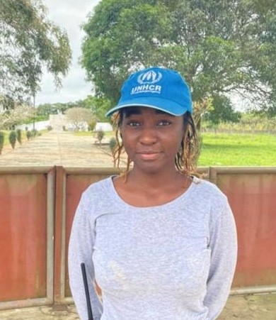
Sonia Muchanga,
Community Based Protection Associate of UNHCR Pemba

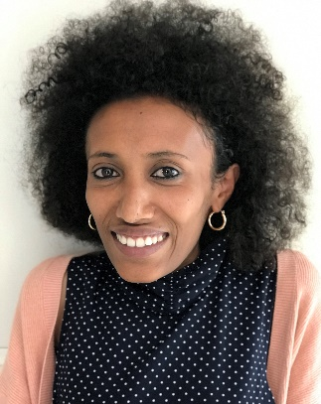

Firehiwot Siyum,
Project Officer, African Disability Forum (ADF)

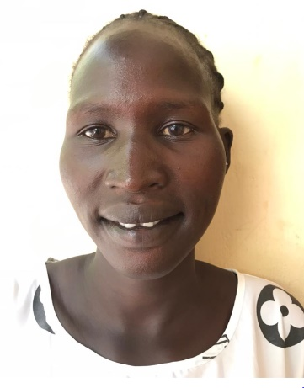

Namuok Tot Mach,
Dadaab Response Association

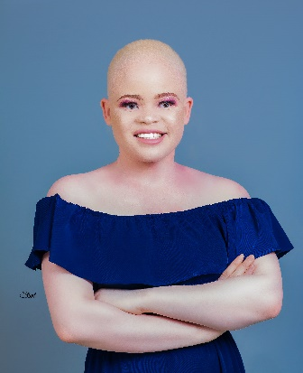

Chikondi Kanjadza,
member of the Association of Persons with Albinism in Malawi (APAM)

