Side Event: Forging Gender Equal, Just and Inclusive Societies: A multi-stakeholder perspective on promoting gender transformative and inclusive development

SPEAKER BIOs:

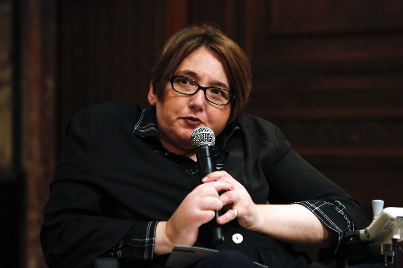 | Dr. Ola Abualghaib: Manager of the Technical Secretariat of the UN Partnership of Persons with Disabilities at UNDP. Ola has over twenty years of experience working on gender and disability in development including in fragile and crisis affected settings in the Arab States, Africa and Asia. Ola was recently featured in the Gender Equality Top 100 list of most influential people in global policy in 2019.
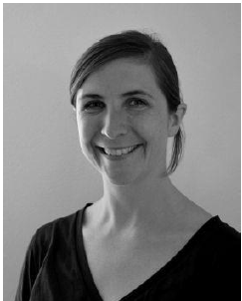 | Krista Orama is Senior Adviser on Gender Equality at the Ministry for Foreign Affairs of Finland. Her professional background is in human rights law, policy and capacity building, with a specialization on a human rights-based approach to development, gender equality, business and human rights, non-discrimination and the rights of persons with disabilities. Before joining the MFA in 2019, Krista worked with the Office of the High Commissioner for Human Rights (OHCHR) and the Danish Institute for Human Rights. In her current role, Ms. Orama advances Finland’s work on the gender transformative and intersectional approaches, focusing especially on the intersection between gender and disability in accordance with Finland’s policy priorities.
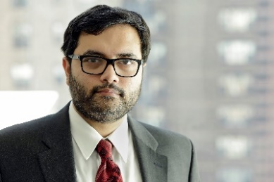 | Dr. A. H. Monjurul KABIR, currently, UN-Women’s Global UN Coordination Adviser for Gender Equality and Disability Inclusion, was the immediate past Chair (2019-20) of the Policy Board and the Management Committee of the UNPRPD Prior to this, Dr. Kabir was Senior Policy and Programme Adviser for Rule of Law, Justice and Security Sector Reform (SSR) with UN-Women. He also served as the Senior Programme Adviser and Chief of Section, Asia-Pacific, LDCs, and SIDS (2014-18) at UN Women HQ. Monjurul, a Governance, Rule of Law, Inclusion and Intersectionality, and, Public Sector Management expert, was the Practice Team Leader and Policy Adviser (2010-14) for Governance and Human Rights for UNDP Europe, and CIS region. He served as the Global Policy Specialist (2006-10) at UNDP Policy Bureau. Dr. Kabir, a public speaker, authored several books and numerous research articles for international publishers, global news media, and academic journals. His most recent book (2019) is on Politics and Aid Effectiveness by Palgrave and Macmillan: Development Aid in Stable Democracies and Fragile States. Dr. Kabir can be reached by e-mail and, be followed at twitter: @mkabir2011
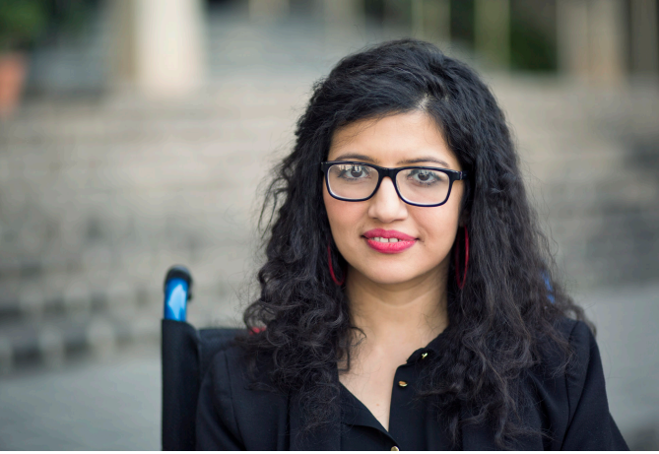 | Abia Akram is the Coordinator of the Global Forum on the Leadership of Women with Disabilities. With a personal experience of physical disability, Abia Akram has been engaged in the activities of Disability Movement since 1997. She has been lobbying with parliamentarians, UN high level representatives focusing on developing advocacy strategies to raise awareness, network, and build capacity and at the UN level in relation to the UN Convention on the Rights of Persons with Disabilities and Inclusive Development. She also coordinates efforts of including persons with disabilities in the implementation of the 2030 Agenda and its sustainable development goals. In particular, she established National Forum of Women with Disabilities, Special Talent Exchange Program (STEP), Ageing and Disability Task Force (ADTF), Commonwealth Young Disabled People’ Forum (CYDP), Global Network of Emerging Young Women, Disabled People International and has been recently assigned the responsibility as Chair, Asia Pacific Women with Disabilities Network. She is the Co-Coordinator, Asia Pacific Women with Disabilities United and Coordinator, South Asia Disability and Development Initiative (SADDI) Project.
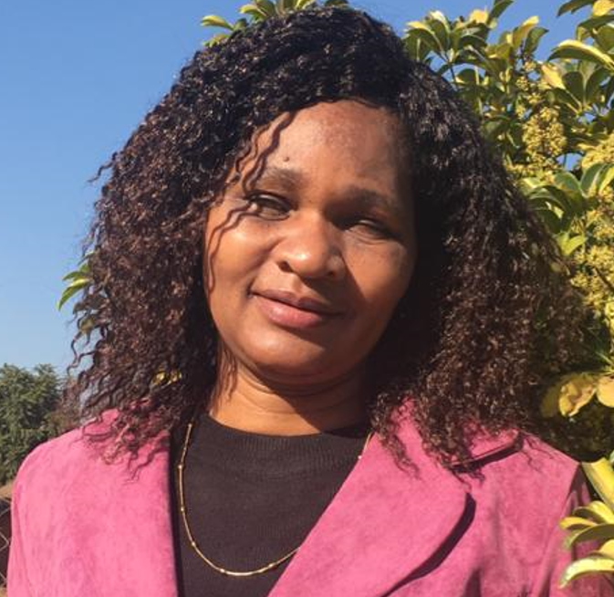 | Elisa Ravengai is a disability Inclusion Specialist at one of two of Zimbabwe’s umbrella bodies- Federation of Organisations of Disabled People in Zimbabwe (FODPZ). She is a member of the Presidential Advisory Council (PAC) which is an independent body of professionals appointed by the President to provide technical advice and to serve as his sounding board for various policy options.
 | Amanda McRae is the Director of United Nations Advocacy at Women Enabled International. Before joining WEI in 2016, Amanda was a Global Advocacy Adviser with the Center for Reproductive Rights, where she conducted oral and written advocacy with U.N. institutions in New York and Geneva. Amanda also served as a researcher at Human Rights Watch, where she focused on human rights issues in the Western Balkans and disability rights worldwide. She conducted one of the first research projects at HRW, or from any general human rights organization, to invoke the CRPD. Amanda holds a J.D. from Duke University School of Law and a B.A. in International Relations/Political Science from Carleton College.

