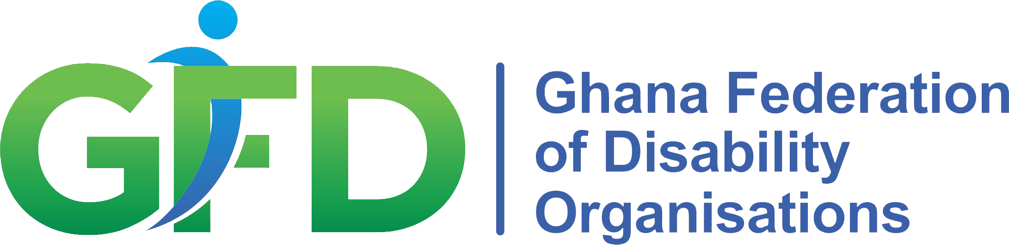
GDS Concert streamed from Oslo and Ghana

Organized by the Atlas Alliance and the Ghana Federation of Disability Organisations
Side-event code:
Date: Thursday, February 17th
Time: 18:30 CET (Central European Time)

Event link (Streaming-link will be posted here on February 17th): Virtual GDS concert with Sidik Kamara and Bendik Hofseth live from Oslo, and the Magic Eye Band live from Accra: https://fb.me/e/1hDBWVJKG

Accessibility: The side event is a concert with a short introduction by the Atlas Alliance and representatives from IDA. The introduction will be interpreted into International Sign and the interpreter will be visible on the screen throughout the event.

Artists:
Bendik Hofseth, Oslo Norway
Sidiki Camara, Oslo Norway
Magic Eye Band, Accra Ghana

-------------------------------------------------------------------------------------------------------------------------------------

To celebrate the end of the summit and to kick off the implementation of the commitments, the Atlas Alliance is hosting a digital concert streamed from Oslo and Accra. The concert will start in Oslo where the highly acclaimed jazz musician Bendik Hofseth will play along with one of the world’s leading percussionists Sidiki Camara. The concert will continue from Accra, where the Magic Eyes Band will take over. The Magic Eyes Band is an extraordinary group of talented visually impaired musicians who have come together to use music as a tool to educate, entertain, and inform.

This is an exciting opportunity to celebrate GDS with the two host nations and promote the acceleration of the much-needed progress towards the fulfilment of the rights of persons with disabilities worldwide.

The concert will be moderated by Gagan Chhabra from the Atlas Alliance and introduced by Morten Eriksen and representatives from the International Disability Alliance.

