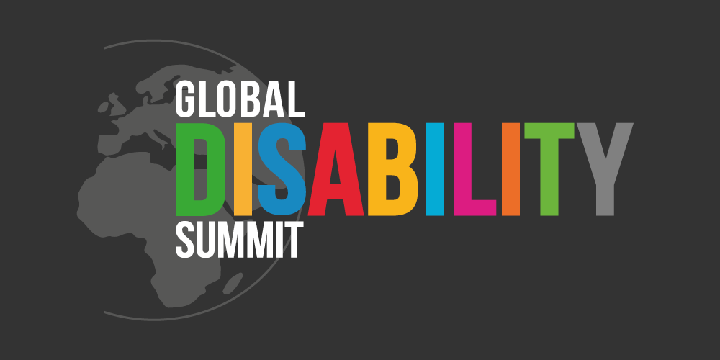
THEMATIC WORKSHOPS
EVENTS 2022

FRIDAY, 14 JANUARY 2022, 2 - 5 PM CET
Mobilizing for Assistive Technology
Towards the 2nd Global Disability Summit
ATscale
REGISTER HERE

THURSDAY, 20 JANUARY 2022, 3 - 4.30 PM CET
Inclusive Education Thematic Workshop
Global Campaign for Education, IDA, World Bank Group, Leonard Cheshire, World Vision, and more
REGISTER HERE

THURSDAY, 27 JANUARY 2022, 3 - 4 PM CET
Thematic Workshop on Community Inclusion
What Can We Do to Build Back Better for Community Inclusion?
UNCHR, Global Action on Disability (GLAD) Network members
REGISTER HERE
REGIONAL SATELLITE SUMMITS

THUESDAY, 8 FEBRUARY 2022, 10 AM - 1 PM CET
High Level European Regional Disability Summit
Perspectives on Pan-European International Cooperation
EDF, Atlas Alliance, IDA, ILO, Norwegian Federation of Organisations of Disabled People (FFO), UN Human Rights Regional Office for Europe, UNDP Europe, UNICEF Europe and Central Asia, UN Partnership on the Rights of Persons with Disabilities Fund, WHO Regional Office for Europe
REGISTER HERE

WEDNESDAY, 16 FEBRUARY 2022, 01:00 PM FIJI ISLANDS, MARSHALL ISLANDS
High Level Pacific Regional Summit
Department of Foreign Affairs and Trade of the Government of Australia, Government of New Zealand, Pacific Disability Forum
REGISTER HERE

WEDNESDAY, 16 FEBRUARY 2022, time: TBC

High Level Regional Summit for Asia
Sustainable and Inclusive Employment of Persons with Disabilities
after COVID-19
Disabled People International Korea, Asian Disability Forum

MAIN EVENTS

MONDAY, 14 FEBRUARY 2022, DAY-LONG LIVESTREAM
Global Disability Youth Summit
IDA, UNICEF, Atlas Alliance, IDA Youth Caucus, Youth Mental Health Norway
REGISTER HERE

TUESDAY, 15 FEBRUARY 2022, 2 - 5 PM CET
Civil Society Forum
Civil Society Reference Group
REGISTER HERE

WEDNESDAY 16 FEBRUARY AND THURSDAY 17 FEBRUARY 2022, 2 - 5 PM CET
Global Disability Summit
Government of Norway, Government of Ghana, International Disability Alliance (IDA)
REGISTER HERE

SIDE EVENTS

WEDNESDAY 16 FEBRUARY AND THURSDAY 17 FEBRUARY 2022
Between 9 AM - 2 PM CET / 3 AM – 8 AM EST
Between 5 PM - 9 PM CET / 11 AM- 3 PM EST

Read about Side Events.
More information will be available in the coming weeks.

