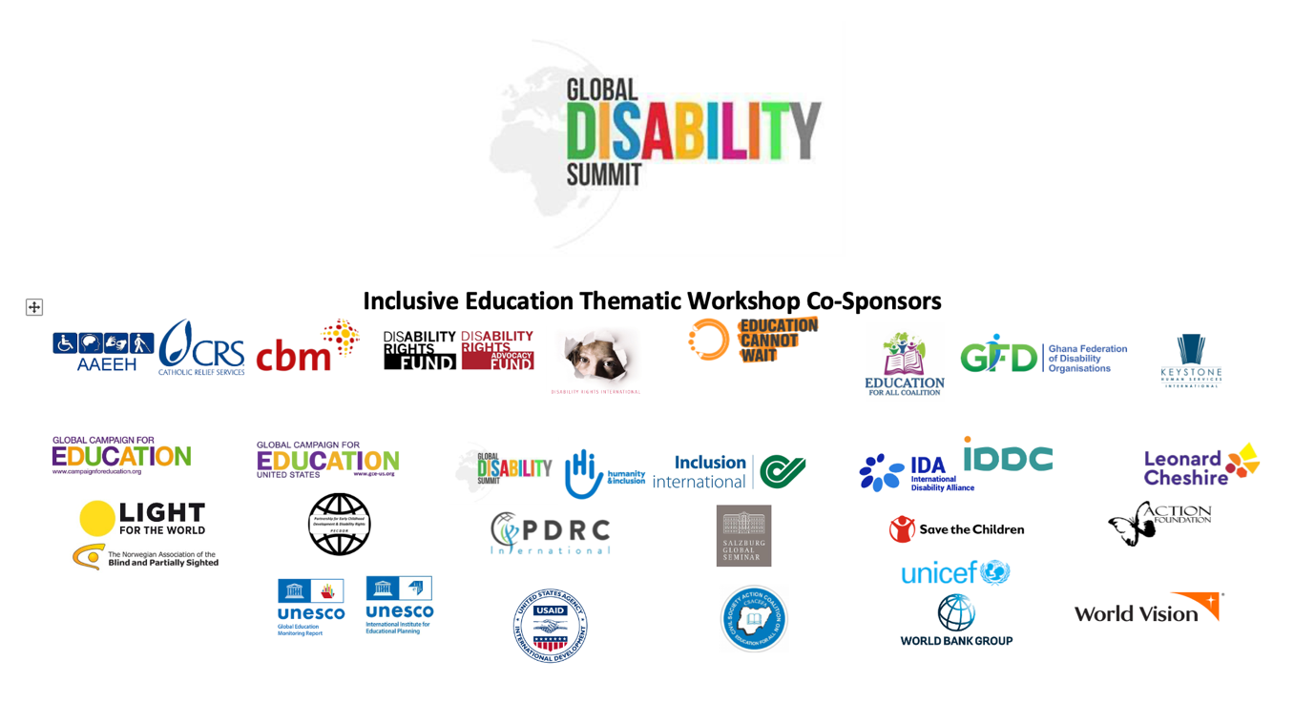

Call to Action: Recommendations from the
Global Disability Summit (GDS22) Thematic Workshop on Inclusive Education

This document represents the outcome of the “Global Disability Summit: Inclusive Education Thematic Workshop” held on 20th January 2022, to promote disability-inclusive education as a high priority for stakeholders making commitments ahead of the 2022 Global Disability Summit. When learners with disabilities are fully included and can access opportunities to reach their full potential, everyone benefits. To realize this vision, States, donors, development and humanitarian actors should engage with organisations of persons with disabilities to enhance disability inclusion in legislative and institutional frameworks, programming and service delivery. Based on the Menu of Commitments developed by the GDS22 organisers, these recommendations point to responsibilities and actions that are needed in these areas to implement CRPD Article 24 and achieve SDG4 for, by, and with learners with disabilities, realising the right to education for all.

The Global Disability Summit highlights the following as key areas requiring action by all actors in 2022:

INCLUSIVE EDUCATION COMMITMENTS

- Strengthen education systems so that they are inclusive of all, including those that face highest risks of marginalisation such as learners with disabilities.
- Recognize that progress in inclusive education depends upon foundations of progress in inclusive nurturing care and inclusive early childhood development; begin at the beginning, learning begins in infancy, expands in early childhood, and continues in pre-primary, primary, secondary systems and beyond.
- Build capacity on inclusive education in the education workforce, including Ministries of Education.
- Strengthen targeted support for learners with disabilities, including provision of social protection in particular towards disability specific costs that impact access to education.
- Promote social inclusion at community level. Support inclusive community services for all children, together with individually tailored services for children with disabilities. Inclusive education is the only way to achieve SDG 4 for all children, including children with disabilities. There should be one system of education and all children, including those with disabilities, must be guaranteed access. Any segregated or special settings that are not in line with the CRPD must be phased out. Failure to include children with disabilities in inclusive school settings in their community undermines community inclusion and leads to increased pressure to place children in special boarding schools or other forms of institutional care.
- Ensure inclusive education in situations of crisis, emergency, and conflict.
- Promote inclusion of persons with disabilities in vocational training and higher education and facilitate access to opportunities for decent work.
- Design and implement cross-sectoral strategies to provide comprehensive support to all learners.
- Increase information and knowledge on inclusive education for policy-making and targeted interventions, including through collection and publication of disaggregated education data.
- Increase sustainable long-term funding for inclusive education.
- Strengthen tracking of disability inclusion in expenditure.

OVERARCHING COMMITMENTS

- Reduce discrimination and stigmatisation by promoting attitudinal change in communities and across all development cooperation, including, addressing intersectionalities.
- Disaggregate data by disability, gender and age in data collection and statistics.
- Commit to tracking expenditure and efforts for inclusion in national accounting and development cooperation.
- Increase consultation and meaningful participation of persons with disabilities and organisations of persons with disabilities in the design, implementation, monitoring and evaluation of national policies and systems, and in international cooperation.
- Support efforts to align existing legislation with the Convention on the Rights of Persons with Disabilities (CRPD), using the participatory approach of law reforms as required by the CRPD.
- Promote accessible information and access to democratic processes and elections, and promote inclusion and diversity in political representation.
- Achieving a fully inclusive education system for all learners including learners with disabilities requires a “twin-track” approach - a transformation across the whole education system to ensure learners with disabilities are fully welcomed and included, whilst also ensuring targeted investments to support the unique needs of learners with disabilities.
- Promote Do No Harm codes of ethical conduct to protect all children and youth, especially from practises that are emotionally, physically damaging, and/or disrespectful.

Assistive Technology

- Support, develop and implement programmes on assistive technology to make them easily available.

Community Inclusion

- Develop cross sectoral policies and design action plans in partnership with the full range of stakeholders and communities to facilitate the meaningful inclusion of all children and adults with disabilities, with a special focus on gender equality.
- Invest in accessible and disability inclusive needs assessment, information management systems, and outreach mechanisms that facilitate coordinated support for community inclusion.
- Invest in transforming, developing, or scaling up person-centric and gender responsive community support and care systems that foster choice and autonomy for the diversity of persons with disabilities across the life cycle.
- Mobilise resources to ensure that public services are inclusive by actively working towards with the aim of removing physical, institutional, and attitudinal barriers.
- Pursue a progressive shift from segregated institutions towards harmonised and community-based support.
- Support multi-stakeholder coordination and efforts to strengthen the knowledge-base on achieving community-based support in different contexts.

The co-hosts of the Global Disability Summit Inclusive Education Thematic Workshop strongly urge all stakeholders to make concrete commitments in these areas to accelerate progress towards achieving quality education for all learners with disabilities and ensuring the achievement of Sustainable Development Goal 4 and Article 24 of the CRPD.

To continue to be engaged in this work, please join the Inclusive Education and Early Childhood Education Community of Practice.

Thank you to the global partners and co-sponsors who made the Global Disability Summited Inclusive Education Thematic Workshop possible, including:

- Association d'Aide à l'Education de l'Enfant Handicapé (AAEEH)
- Catholic Relief Services (CRS)
- CBM
- Civil Society Action Coalition on Education for All (CSACEFA)
- Disability Rights Fund & Disability Rights Advocacy Fund
- Disability Rights International
- Education Cannot Wait
- Education for All Coalition
- Ghana Federation of Disability Organisations (GFD)
- Global Campaign for Education
- Global Campaign for Education-US
- Global Disability Summit
- Global Education Monitoring Report
- Humanity & Inclusion
- Inclusion International
- International Disability Alliance
- International Disability and Development Consortium (IDDC)
- Keystone Human Services International
- Light for the World
- Leonard Cheshire
- Norwegian Association of the Blind and Partially Sighted (NABP)
- Partnership for Early Childhood Development & Disability Rights (PECDDR)
- PDRC International
- Salzburg Global Seminar
- Save the Children
- The Action Foundation
- The World Bank
- UNESCO International Institute for Educational Planning
- UNICEF
- USAID
- World Vision

The International Disability Alliance (IDA), the Government of Norway, and the Government of Ghana will (virtually) host the second Global Disability Summit on 16 and 17 February 2022 (GDS22). Link: https://www.globaldisabilitysummit.org

