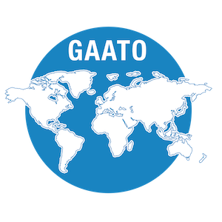
Global Disability Summit Side Event 30
"Assistive Technology for inclusion - measuring our outcomes"
Organised by: GAATO (Global Alliance of Assistive Technology Organisations)
Side-event date and time: 1.00 – 2.00pm CET Wednesday, 16 February
Registration Link is HERE (link in full https://forms.gle/teeKjhucmDFqVUw4A)
Assistive technology and GAATO
The Global Alliance of Assistive Technology Organizations (GAATO) www.gaato.org is a non-profit association proud to be a voice for all those dedicated to creating and using assistive technology. GAATO works to further the provision of quality assistive products and rehabilitation services around the world.
What is this event about?
GAATO is identifying global Grand Challenges in AT outcomes. We have consulted over 300 stakeholders from over 50 countries through multiple Regional Consultations during 2020. This session will discuss outcomes data to date, with a global audience. The Challenges will:
- • Identify what is needed to be able to measure assistive technology outcomes and impact at the individual, community, local, national, and global level.
- • Discover what people think is needed as tools for data collection, data storage and use, outcomes related systems and their implementation, best practices, and policies
- • Ensure AT outcomes funding / actions are appropriate for AT stakeholders across the globe
Leading up to the Global Report on Assistive Technology, GAATO invites participants to share views on AT Outcomes through a Grand Challenge process. GAATO aims to identify a set of challenges which address what is needed to be able to measure assistive technology outcomes and impact at the individual, community, local, national, and global level.
What will the Side Event cover?
Register if you would like to:
- Learn more about assistive technology and the outcomes it supports
- Hear about assistive technology priority outcomes from over 300 participants from 57 countries across all WHO Health Regions.
- Discuss a consolidated list of regional Grand Challenges
- Contribute to identifying, consolidating, and prioritizing challenges in assistive technology outcome, to inform the forthcoming WHO/ UNICEF Global report on Assistive Technology.
More information?
secretary@gaato.org

