Communication Toolkit

Event: Evidence based programmes for disability inclusion: The UNPRPD MPTF innovative approach to support participatory system and policy change.
Platform: Zoom – Webinar
Session time: Thursday, 3 February 2022, 9.00-10.30 a.m. (EST), 1 hour 30 min
Language: The session will be held in English and feature simultaneous interpretation in International Sign (IS) and real time captioning.
Registration Link: https://undp.zoom.us/webinar/register/WN_5Jix3KN9TfCFrAUgotZv8g

Suggested Tweet
As we approach the #GDS2022, join @UNDP and @unprpd to discuss evidence-based programmes for #disabilityinclusion with @IDA_CRPD_Forum, @AtlasAlliansen, @ICED_LSHTM and @LSHTM.
Co-sponsored by @NorwayMFA and @dfat
📅 3 Feb 2022, 9.00-10.30 EST
👉Register: https://undp.zoom.us/webinar/register/WN_5Jix3KN9TfCFrAUgotZv8g

Suggested photo tags
@UNDPgov, @UNDPNorway, @GDS_Disability, @AlghaibOla, @HaoliangXu, @hannahkuper1, @VIERAJOSEMARIA, @bweibahr, @CDPO_NGO

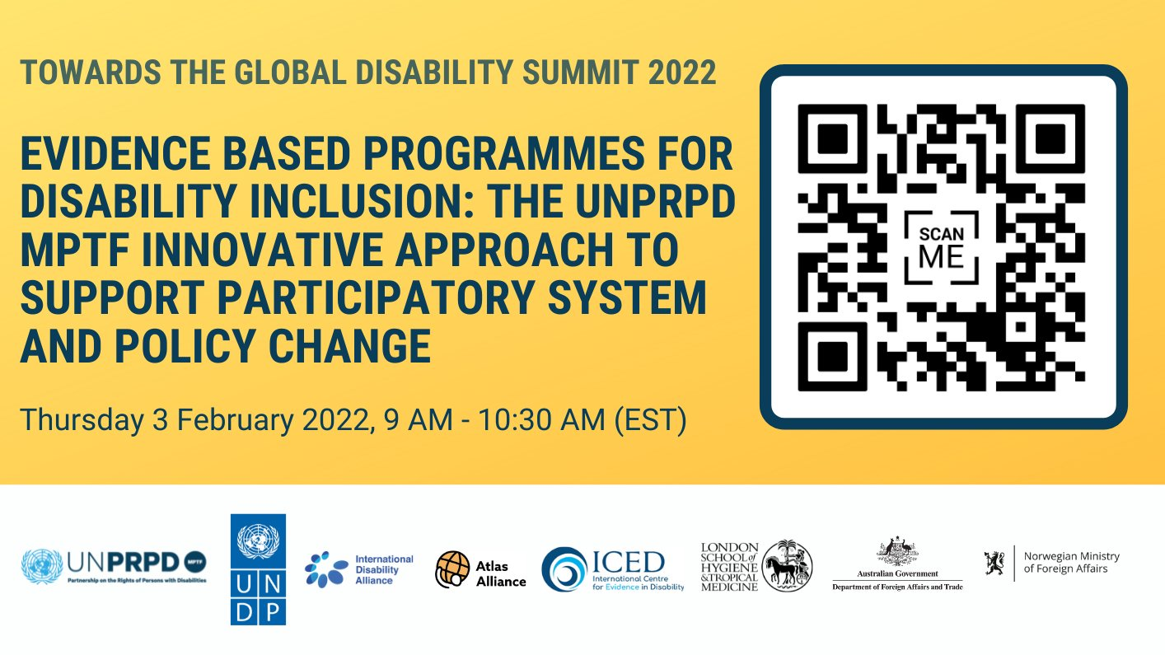
Suggested Photo

Suggested Alt Text for Picture
Once you upload the picture on Twitter (and before tweeting) please add the following AltText by clicking “Add description”
‘‘Picture advertising the event “Evidence based programmes for disability inclusion: The UNPRPD MPTF innovative approach to support participatory system and policy change” with dedicated QR Code for registration and logos of UNPRPD MPTF, UNDP, International Disability Alliance, Atlas Alliance, the International Centre for Evidence in Disability, the London School of Hygiene and Tropical Medicine, the Department of Foreign Affairs and Trade in Australia and the Ministry of Foreign Affairs in Norway’

Twitter handles
@ZMilisic
@unprpd
@UNDPgov
@UNDP
@UNDPPA
@GDS_Disability
@NorwayMFA
@dfat
@IDA_CRPD_Forum
@AtlasAlliansen
@LSHTM
@AlghaibOla
@HaoliangXu
@hannahkuper1
@VIERAJOSEMARIA

Hashtags
#CRPD #SDGs #GDS2022 #disabilityinclusion #disabilityrights #EveryoneIncluded

Contacts
- Alessandro Ercolani, UNDP at alessandro.ercolani@undp.org and Kavitha Thiyagarajah, UNPRPD at kavitha.thiyagarajah@undp.org

