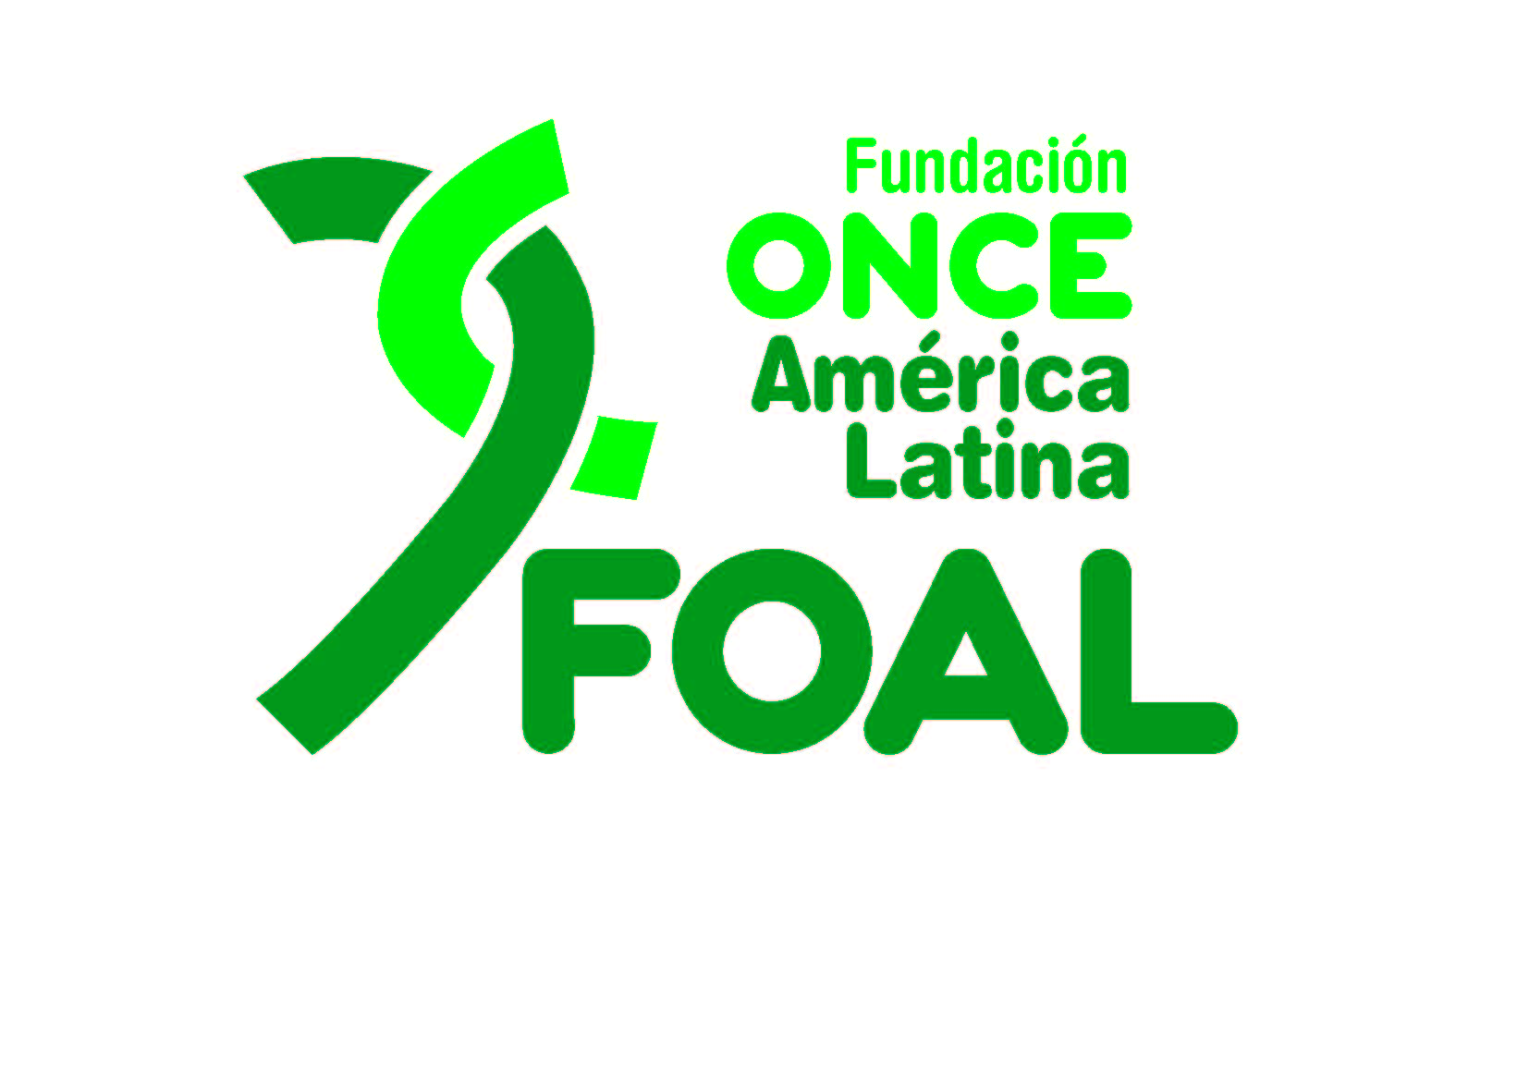
Sharing good practises from Latin America on DPO engagement in designing and implementing state public development policies in order to leave no one behind.
Thursday, 17 February at 6.00 pm CET
This event is a commitment to the future of persons with disabilities and aims to show how they and their representative organisations undoubtedly contribute to building a society where equal opportunities are a reality. For this to happen, public policies must be inclusive and governments must accept their responsibility in this respect decisively and unconditionally.

Civil society, via its untiring advocacy efforts and, on many occasions, working together with different governments, is truly contributing in order to “leave no one behind”.

FOAL is an expression of this commitment because we believe in a global model for inclusion which is open, sustainable and unique and which seeks to ensure autonomy and visibility for persons with disabilities. FOAL is now highly regarded internationally.

Overall goal:

Facilitate and support an exchange of experiences and good practises in designing and implementing state-run public policies to fulfil the UN Convention on the Rights of Persons with Disabilities and the 2030 Agenda.

Specific goals:

- Disseminate information on the mechanisms states offer to enable the participation of organisations of persons with disability in drafting, implementing, monitoring and assessing public policies.

- Share the experience of how an organisation of persons with visual impairment working in the field delivers its advocacy efforts with governments to ensure public policies are inclusive, thus putting into practise the fundamental principle of “nothing about people with disabilities without people with disabilities.”

- Present a technical support model through international co-operation by an NGDO managed by persons with visual impairment. Thanks to this model and by means of concrete projects linked to key areas such as education, employment and habilitation and rehabilitation, these public policies are made inclusive, accessible and sustainable.

Interpretation will be available in Spanish and English. Captioning in English and international sign-language interpretation will also be provided.

Target Groups

- States.
- National disability councils.
- Organisations of persons with disabilities.
- Development NGOs.

speakers

- Moderator: Catalina Devandas Aguilar, Ambassador Permanent Representative. Permanent Mission of Costa Rica in tne UN in Geneva.

Panelists:

- Carla Bacigalupo Planás, Employment Minister (Ministry of Lavor, Employment and Social Security IN Paraguay).
- Nadia Celina García Molina, President of the Asociation of the Blind El Salvador (ASCES)
- Estefanía Mirpuri Merino, CEO FOAL.

About us
The ONCE Foundation for Latin America (FOAL in Spanish) was founded in 1998 and through it, ONCE extends its solidarity to people with a visual impairment in Latin America.
FOAL’s work focuses on educational, employment and social inclusion of people who are blind or low vision in 19 Latin American countries, in line with the United Nations Convention on the Rights of Persons with Disabilities. Through its work, it is also contributing to advancing the Sustainable Development Goals within the framework of the 2030 Agenda.

Stronger together
FOAL contributes to strengthening organisations of blind people in the following ways:
• Supporting the activities of organisations of people with a visual impairment in the region.
• Promoting unity as a value to achieve improvements that guarantee the rights of people who are blind or low vision.
• Involving national and local associations of the blind in the programmes and projects it delivers in their area.
• Promoting activities aimed at enhancing their capacity, services and professionalisation.

