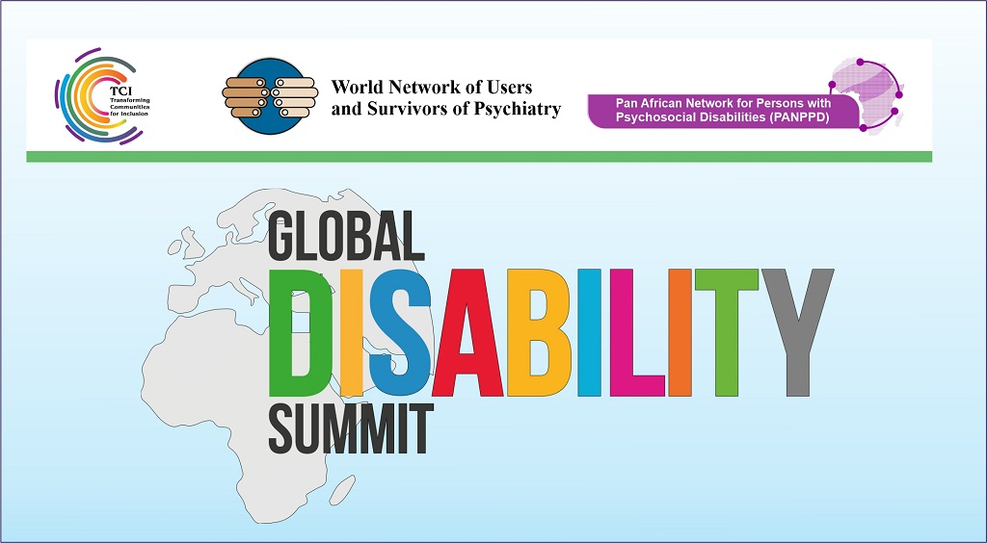

Capacity strengthening of Organizations of Persons with Psychosocial Disabilities

At the Global Disability Summit 2022
Side event No. 27, Wednesday 16th February, 1.00 PM CET – 2.00 PM CET

Registration Link: https://zoom.us/webinar/register/WN_o6qnbSGCT42Y48EK-ZUv_w

Transforming Communities for Inclusion (TCI), in collaboration with PANPDD and WNUSP is offering a side event during GDS 2022 on the theme : ‘Capacity-strengthening of organizations of persons with psychosocial disabilities in the Global South’.

Article (4.3) of the Convention on the Rights of Persons with Disabilities is held sacrosanct in the disability movements worldwide, on the full and effective participation of all persons with disabilities. However, persons with psychosocial disabilities, users and survivors of psychiatry, ‘mad’ persons and persons with intersectional, neuro-diverse identities, continue to be marginalized, ignored, and their voices unheard in high level policy circles including in the GDS. We are invisible in the Agenda 2030, HPLF and other such initiatives on SDGs.

More worrying is the fact that, within the disability and human rights universe of discourses, we are put in the box of ‘right to mental health care’. We notice a tsunami of ‘mental health- ification’ of human rights, pushing us back to just being (forced) subjects of health care and closed door institutions. This limits our access to the open world and its opportunities for inclusion through the realization of civil, political, social, economic and cultural rights as prescribed by the CRPD. This disregard for our role as DPOs, hard won by the WNUSP in the making of the CRPD, reinforce the conventional ‘mental health’ paradigm, with its core theme of ‘coercion’, even after 15 years of the CRPD being in force throughout the world.
As a marginalized disability constituency, we need excellent and inclusive services, which will give us opportunity for living independently in inclusive communities. However, investments have continued in the direction of ‘reforming’ mental health care. Governments, different ministries, technical support organizations and service providers in the disability sector, cross disability organizations and global disability organizations are not inclusive of our constituency, in a genuinely respectful way.
The voice of our movement (as users and survivors, 'mad persons', persons with psychosocial disabilities or variants thereof) has been left out, including in the GDS. The side event will call out this issue to all governments, global technical support organizations and cross disability organizations working in global landscape, to recognize us as belonging in the disability sector; share opportunities with us for full and genuine inclusion, and the realization of article 4.3 to enable our full and effective participation.
TCI, along with our partners, PANPDD and WNUSP, share our experiences of working as regional DPOs, and effective strategies for DPO development, in the global south; in our question for equal participation.

