Presentation of main findings from UNICEF’s Global Report on Children with Disabilities
Side Event - Global Disability Summit (GDS2022)

Date 17 February 2022 | Hours 13:00 – 14:00 Eastern Standard Time | 19:00 – 20:00 Central European Time
Location Virtual (Zoom) https://unicef.zoom.us/webinar/register/WN_GiPl7Y7GTgytPxRUCKdKxA

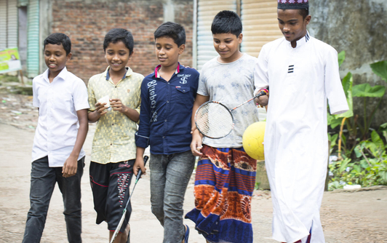

Recent years have seen renewed interest in generating reliable and internationally comparable data on children with disabilities. This has led to the development of new research and tools for data collection, including the Child Functioning Module, released by UNICEF and the Washington Group on Disability Statistics in 2016. It has also resulted in a substantial increase in the availability of data on children with disabilities over the last five years, fostering new data analyses and contributing to increased knowledge generation.
The side event will feature a presentation of UNICEF’ latest data report Seen, Counted, Included: Using data to shed light on the well-being of children with disabilities. It will also provide an opportunity to talk about persisting data and evidence gaps and ways to overcome them. In particular, the event will include a presentation of the work and activities of the Centre of Excellence on Data for Children with Disabilities, and the Global Research Agenda and Platform for Children with Disabilities.

Agenda

Welcoming remarks and presentation of Seen, Counted, Included: Using data to shed light on the well-being of children with disabilities (20 minutes)
- Claudia Cappa, Senior Adviser, Statistics and Monitoring, UNICEF Data and Analytics Section
The publication presents data from over 40 countries and covers more than 60 indicators of child well-being – from nutrition and health, to access to water and sanitation, protection from violence and exploitation, and education. The report also includes the first-ever global and regional estimates of children with disabilities.

Presentation of the Centre of Excellence on Data for Children with Disabilities (10 minutes)
- Julie D. Weeks, National Centre for Health Statistics and Washington Group on Disability Statistics
The centre aims to promote the generation of robust and relevant statistics for use in both decision-making and advocacy. In particular, the Centre will help fill data gaps, improve accessibility of data and promote data use. It will also foster collaboration, standardization of approaches to data production and dissemination, and coordination of data activities. The initiative is meant to bring together international organizations, organizations of persons with disabilities, academics and national statistical offices around a shared commitment to strengthening the availability and quality of statistics on children with disabilities.

Presentation of the Global Research Agenda and Platform for Children with Disabilities (10 minutes)
- Gavin Wood, Research Facilitation and Knowledge Management, UNICEF Office of Research – Innocenti
Reinforcing its GDS22 commitments on research and evidence generation, UNICEF will present progress towards a dedicated Global Research Agenda and Platform for Children with Disabilities. The vision is a network of academic institutions, researchers, policymakers, donors and practitioners, that includes lived experience, and amplify the voice of children and youth with disabilities; a platform that advocates for global collaboration around a shared agenda, especially of research capacity in the Global South and identify opportunities for investing in research capacity building, to work with Organisations of Persons with Disabilities. UNICEF is currently completing an evidence mapping of research coverage and gaps on children with disabilities and will present how the research agenda, platform and evidence mapping intersect with the core themes of GDS22.

Open discussion and closing remarks (20 minutes)

Sign language interpretation and closed captioning will be provided

