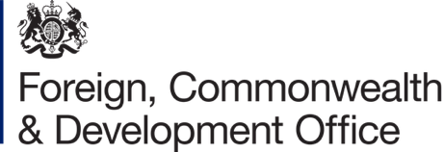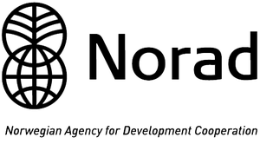

INVITATION

On the occasion of the Global Disability Summit 2022 (GDS22)

The Disability Rights Fund (DRF)/ Disability Rights Advocacy Fund (DRAF), the United Kingdom’s Foreign, Commonwealth and Development Office (FCDO) and Norwegian Agency for Development Cooperation (NORAD)

invite you to attend

What Works: Resourcing OPDs in the Global South to secure and implement GDS commitments

Date: 17th February, 2022 (Thursday)
Time: 6:30am to 8am EST/ 12:30 to 2pm CET
Registration: https://bit.ly/3AzdV6V

Between 2018 through 2021, the Disability Rights Fund (DRF) awarded a total of 38 Global Disability Summit 2018 (GDS18) grants totaling USD 1.61 MN to 22 OPDs in Africa, Asia, and Europe. This side event will bring together OPD and donor voices to highlight what strategies work best for resourcing OPD capacities to lead advocacy efforts to secure commitments from their governments and ensure these commitments are reflected in national level policies and programs. The event will also highlight the importance of shifting power and resources in the hands of southern led OPDs, to sustain long-term change on the ground.

Speakers:
- Opening remarks by Penny Innes, Head of Disability Inclusion Team, UK Government’s Foreign, Commonwealth and Development Office (FCDO)
- Remarks by a NORAD Representative (TBC)
- Albert Mollah, Co-Founder and Executive Director, Access Bangladesh Foundation (ABF), Bangladesh
- Esther Kyoriza, Executive Director, National Union of Disabled Persons of Uganda (NUDIPU), Uganda
- Gaudence Mushimiyana, Co-Founder, Umuryango Nyarwanda w’Abagore Bafite Ubumuga (UNABU)
- Risnawati Utami, Founder, OHANA Indonesia and UN CRPD Committee Member
- OPD Representative from Ghana (TBC)
- Katiya Sakala, Regional Head of Programs – Africa, DRF/ DRAF (Moderator)

