Inclusion Game for Health Equity

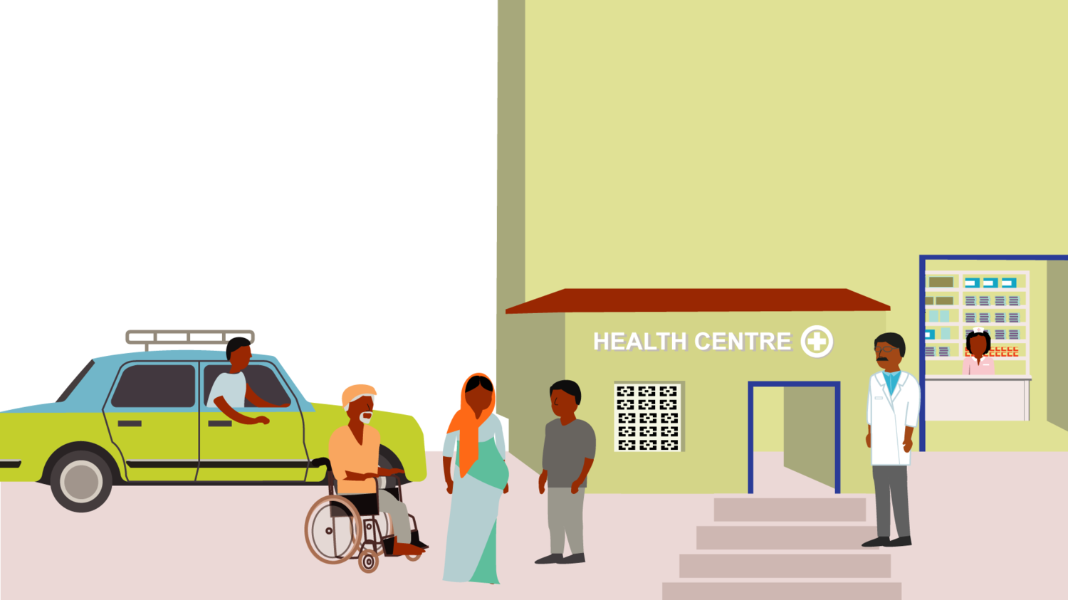

Highest attainable health standard for EveryBODY

According to the World Health Organization, “the enjoyment of the highest attainable standard of health is one of the fundamental rights of very human being without distinction of race, religion, political belief, economic or social condition”. Although both the inclusion of persons with disabilities in various areas of their life span as well as the topic of Sexual and Reproductive Health and Rights (SRHR) has gained considerable momentum in the part years, SRHR for persons with disability still remains a much overlooked and underfunded area of work. The Liliane Foundation sees SRHR as an integral part of every human life, including that of young people with disabilities. We invest in advocacy and in special programmes to ensure that the rights of young people with disabilities are recognized, and that (sexual and reproductive) health services are available and accessible.

The Inclusion Game
The Liliane Foundation invites you to play the Inclusion Game with us during the virtual Global Disability Summit 2022. Discover what barriers people with a disability face when they try to make use of health care services. How to enter a health center? How to find and access information? How to counter stimatising beliefs about (sexual and reproductive) health needs? Think along with us to find creative solutions to advocate for disability inclusion in health care in general and Sexual and Reproductive Health Rights in particular. Because EveryBODY has the right to enjoy the highest attainable standard of health.

Disability inclusion should not be a heavy topic or a burden, but energizing and a great thing to do. With that thought, SeeYou Foundation developed the Inclusion Game.

Why play?
In the game, four characters with different disabilities and other vulnerabilities come to a health care center for a check-up. In going through the health screening, they face a several barriers ranging from how to get in, to how to access SRHR services. Participants play the role of health workers and have to come up with solutions that can be implemented directly and think about sustainable solutions. The aim is to come up with concrete and tangible ideas to advocate for health equity for persons with disabilities that can be adapted in the professional life and activities of the participants.

For whom?
The game raises awareness of the barriers people with disabilities face when accessing health services in general and SRHR in particular. Furthermore the complex intersections of marginalisations become visible. We require customised solutions to ensure equitable access for all.

The game is suitable for:
- Disability inclusion workers
- NGO workers
- Civil servants of Health departments
- Health workers
- Sponsors and donors

In short
WHAT? Inclusion Game for Health Equity, side event of the Global Disability Summit 2022
WHEN? Wednesday, February 16th, 10.00 till 11.30 hrs CET
WHERE? Online event
REGISTER AT https://www.eventbrite.com/e/everybody-matters-play-the-inclusion-game-for-health-equity-registration-254628670207

Live captions will be available. If you request additional services, please indicate so in the online form.

Please note that access is limited to 40 persons, so register quickly!

