ON-BOARD TOWARDS A SAFER AND INCLUSIVE FUTURE FOR GIRLS AND WOMEN WITH DISABILITIES IN EASTERN AND SOUTHERN AFRICA

SIDE-EVENT TO THE GLOBAL DISABILITY SUMMIT 2022

Co-sponsors: UNICEF, ADF, UNFPA, UN Women, and UNHCR
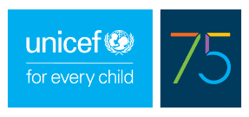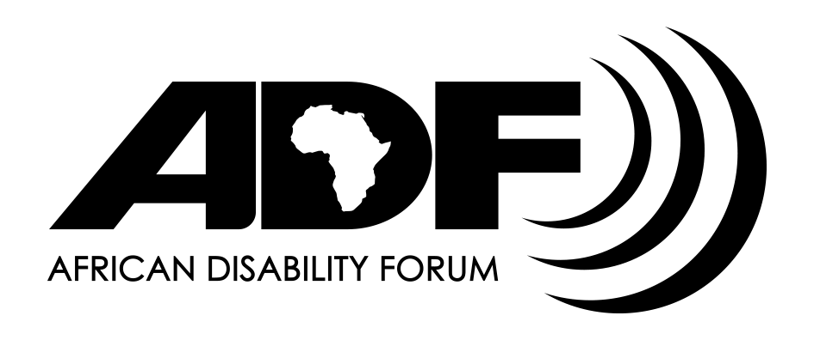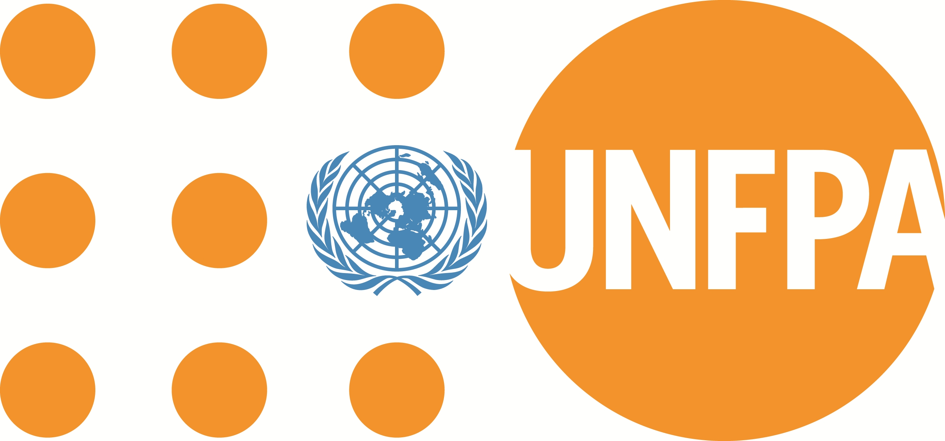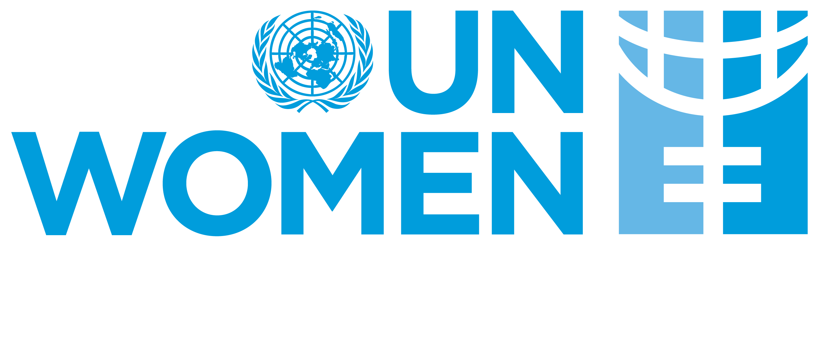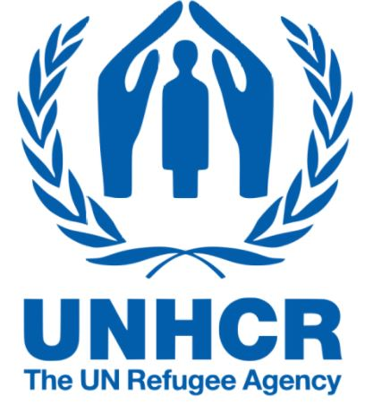

The side-event will bring together government officials, donors, multilateral organisations and civil society, with a focus on how to include all women and girls with disabilities in services and programmes and empower Organizations of Persons with Disabilities to work in emergency situations.
The event is open to all participants and will have ISL, CART and English-French translation.
Time: 17 February 12.00 – 13.15 EAT
Platform: Zoom
Registration link:
https://unfpa.zoom.us/meeting/register/tZIvd-mgqDIiG9RhF4atLsSVw_D0lWnnodgy
Ending the prevailing multidimensional discrimination and exclusion of girls and women with disabilities requires a multi-stakeholder engagement and contributes to the realization of the leave no one behind principle that we collectively strive to achieve. It is important we break silos and build synergies to overcome the various barriers impeding girls and women with disabilities from accessing information and services both in development and humanitarian settings.
Several stakeholders, including organizations of women with disabilities, are coming together under the auspices of the Global Disability Summit 2022 to share their experiences and highlight the key intervention areas that need to be prioritized by regional UN entities and other partners. UN regional entities will share their reflections on commitments and opportunities to deepen engagement and leadership of girls and women with disabilities in advancing the 2030 Agenda.

